Examples of Screen-Print Related Parameters
Examples of Screen-Print Related Parameters
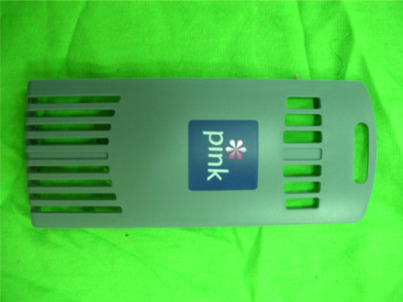
A. | Screen Mesh: 300 mesh
B. | Screen Material: Nylon
 | Because the printed object is curved, the elastic screen is needed to prevent squeegee from deformation
C. | Printed Object Material: ABS
D. | Ink: Find Cause Ink (ABS Special Ink)
E. | Solvent: Find Cause Solvent (Slow Evaporating)
F. | The Amount of Solvent Added: 6%
G. | Squeegee Used: 70 Degree Bevel Squeege
H. | 1.5mm Height between Screen Plate and Printed Object: 1.5mm
I. | Scraping Direction: Left to Right
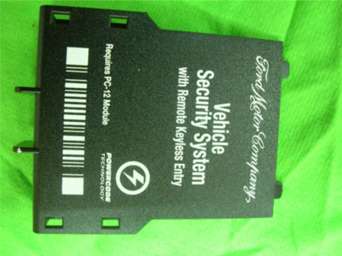
A. | Screen Mesh: 300 mesh
B. | Screen Material: Tetoron
 | We use harder screen cloth because the squeege will leave the screen instantly after scarping. This can reduce ink diffusion.
C. | Printed Object Material: ABS
D. | Find Cause Ink (ABS Special Ink)
E. | Solvent: Find Cause Solvent (Slow Evaporating)
F. | The Amount of Solvent Added: 6%
G. | Squeegee Used: 80 Degree Rectangular Squeegee
 | There is etching pattern on the surface of the printed object. Threrefore, we use harder rectangular squeegee so that the it is sealed with printed object when scarping.
H. | Height between Screen Plate and Printed Object: 2.5mm
I. | Scraping Direction: Left to Right
A. | Screen Mesh: 300 mesh
B. | Screen Material: Tetoron
 | We use harder screen cloth because the squeege will leave the screen instantly after scarping. This can reduce ink diffusion.
C. | Printed Object Material: ABS
D. | Find Cause Ink (ABS Special Ink)
E. | Find Cause Solvent (Slow Evaporating)
F. | The Amount of Solvent Added: 8%
G. | Squeegee Used: 70 Degree Rectangula Squeege
 | The surface of the printed object is flat and smooth. Therefore, we use regular rectangular squeegee so that it will not damage the screen when scarping.
H. | Height between Screen Plate and Printed Object: 2mm
I. | Scraping Direction: Left to Right

